**CHAPTER 5**

**System Analysis and Design**

The project scope is defined and the existing methodologies that are commonly used in software development projects now-a-days in IT industry are discussed then the adopted methodology for completing the project is determined and then the reasons for readopting that methodology are discussed. Following this step, the durations for the various tasks necessary to complete the work are listed and grouped into a work breakdown structure.

System analysis is referred to the systematic examination or detailed study of a system in order to identify problems of the system, and using the information gathered in the analysis stage to recommend improvements or solution to the system. System design is also the overall plan or blueprint for how to obtain answer to the question being asked. The design specifies which of the various type of approach.

**5.1 System Analysis**

The act, process, or profession of studying an activity (as a procedure, a business, or a physiological function) typically by mathematical means in order to define its goals or purposes and to discover operations and procedures for accomplishing them most efficiently.

Another view sees system analysis as a problem-solving technique that decomposes a system into its component pieces for the purpose of the studying how well those component parts work and interact to accomplish their purpose. Analysis and synthesis, as scientific methods, always go hand in hand; they complement one another. Every synthesis builds upon the results of a preceding analysis, and every analysis requires a subsequent synthesis in order to verify and correct its results. The field of system analysis relates closely to requirements analysis or to operations research. It is also “an explicit formal inquiry carried out to help a decision maker identify a better course of action and make a better decision

then she might otherwise have made.

System analysis is the study of sets of interacting entities, including computer systems analysis. This field is closely related to requirements analysis or operations research. It is

also “an explicit formal inquiry carried out to help someone identify a better course of

action and make a better decision than he might otherwise have made.  System Analysis is a methodology that involves the application of systematic approaches to collects facts about an existing system with the aim of improving it or replacing it with more efficient system within the context of the available resources. In other words, System analysis can also be viewed as the process of investigating a system, identifying problems and using the information to recommend improvements to the system.

**Analysis of Existing System**

Before we analyses the design of the proposed system, we need to carefully highlight the problems of the existing system so as to avoid recurrence. Every day, millions of blood specimens are analyzed as part of routine clinical work in hospitals and medical practices throughout the world. Laboratory tests performed are analyzed in clinical laboratories and are usually recorded in computer-based laboratory information systems.

* Too much workload on employees
* Filing cabinet in the pharmacy with paper record.
* Sample pickup facility is not implemented.
* Appointments can’t be booked.
* Patients can’t checkout various tests available.
* Patients can’t post queries to the lab or contact lab attendants.

**Analysis of Proposed System**

From the problems listed in the existing system, the implementation of the proposed system shall focus on;

* Pharmacists having access to the proposed system at any time.
* Reducing the employees’ workload.
* Improving the efficiency of the system by ensuring effective monitoring of services and activities.
* Resolving customer queries.
* Providing interface to the users webforms to book appointments, sample pickups, contacting etc.
* Keeping records of patients in laboratory database.

**5.2 Requirements Definition**

Preliminary investigation plays an important role in developing a satisfactory requirement. Its’ as a result of thorough investigation of how the current or the existing system works using the facts gathered at the preliminary investigation that leads to focusing on the possibility of replacing the existing system or improving upon the existing system. This task involves information gathering.

**Method of Information Gathering**

Collection of fact is the act of getting and gathering information from various sources in order to be able to compose the project. Data used for designing of the system were gathered through several means. Therefore, the method used in the design and collections of information from various sources are as follows:

* Collecting and analyzing existing materials on the project topic, written by different expert.
* Studying the present system in detail and the organizational style.
* Knowing and understanding the input and output processes of the existing system.
* Interviews: A qualitative form of interview was conducted in the pharmacy to know the equipment needed, and the mode of operation of the old system.
* Primary data: This source has to do with the text book contacted for the development of this project.

**5.3 System Design**

* Systems design could be seen as the application of systems theory to product development. There is some overlap with the disciplines of systems analysis, systems architecture and systems engineering.
* System design is the process of defining the architecture, components, modules, interfaces, and data for a system to satisfy specified requirements through system modeling. One could see it as the application of systems theory to produce development. The design of this system will be user friendly. It shall be designed in such a way that employees will be able to navigate easily through the information supplied on the system.
* In other words, system design consists of design activities that produce system specifications satisfying the functional requirements that were developed in the system analysis process. System design specifies how the system will accomplish. System design is the structural implementation of the system analysis.

**5.3.1 SCREENSHOTS**

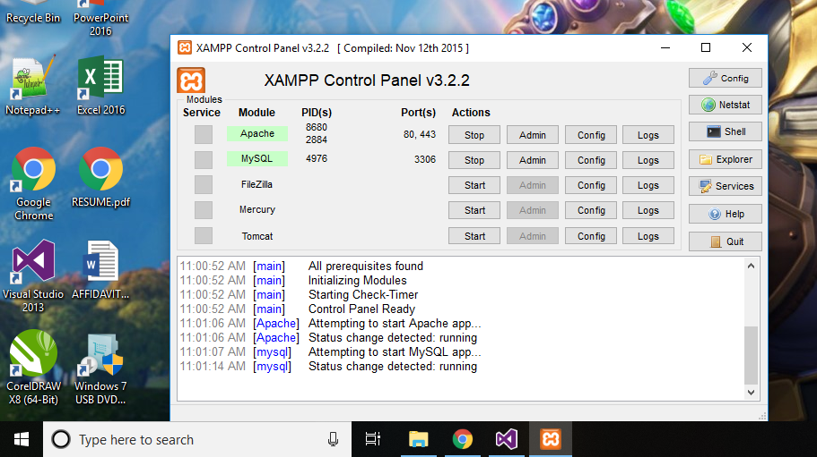

Fig 1: Xampp Server

Xampp is a free and open-source cross-platform web server solution stack package developed by Apache friends, consisting of the mainly of the Apache HTTP server, MariaDB database, and interpreters for scripts written in PHP and Perl programming languages.

And in this project Xampp server is used for MySQL database connectivity.

Fig 2 shows solution explorer in Visual Studio which serves and file manager to manage aspx, C# and other files and folders.

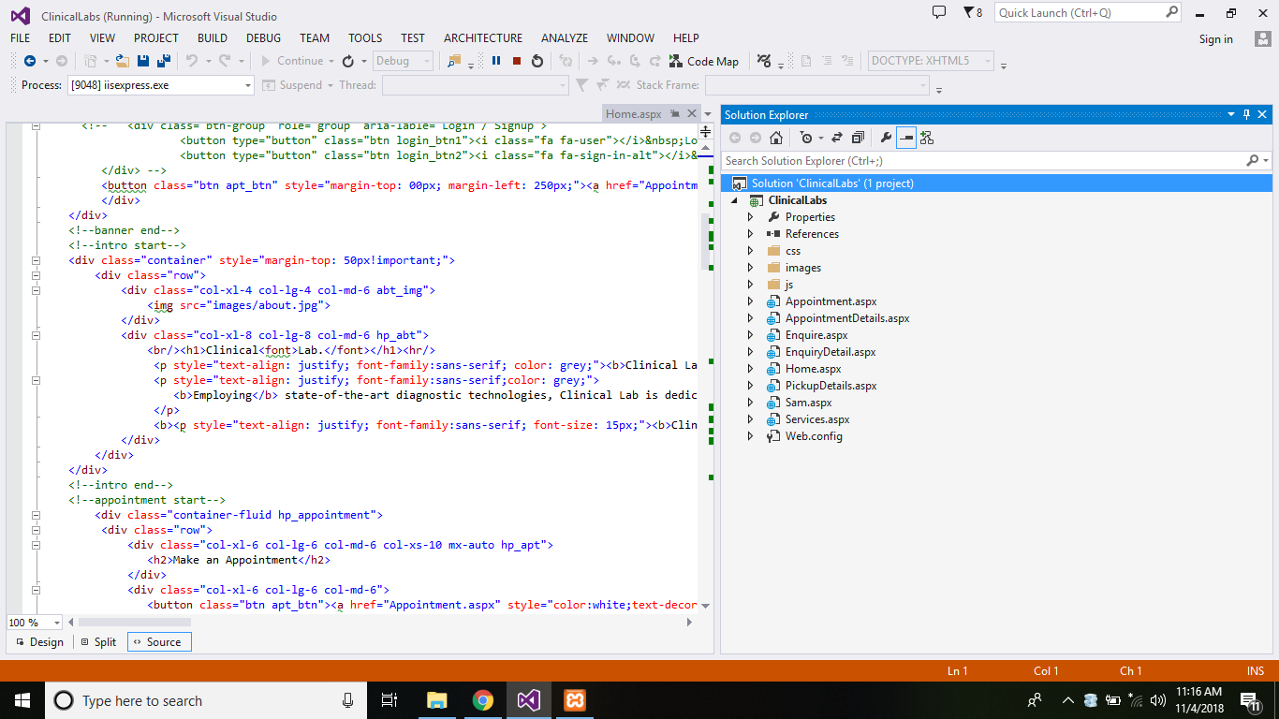

Fig 2: Solution Explorer

Fig 3 shows home page of the of the web application which contains various information

About the clinical laboratory.

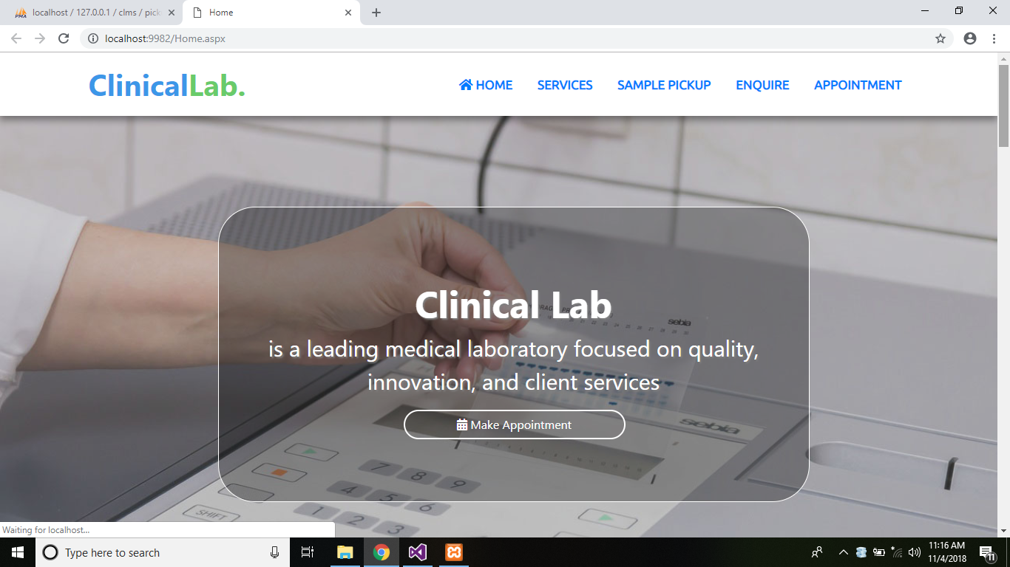

Fig 3: Home Page (Home.aspx)

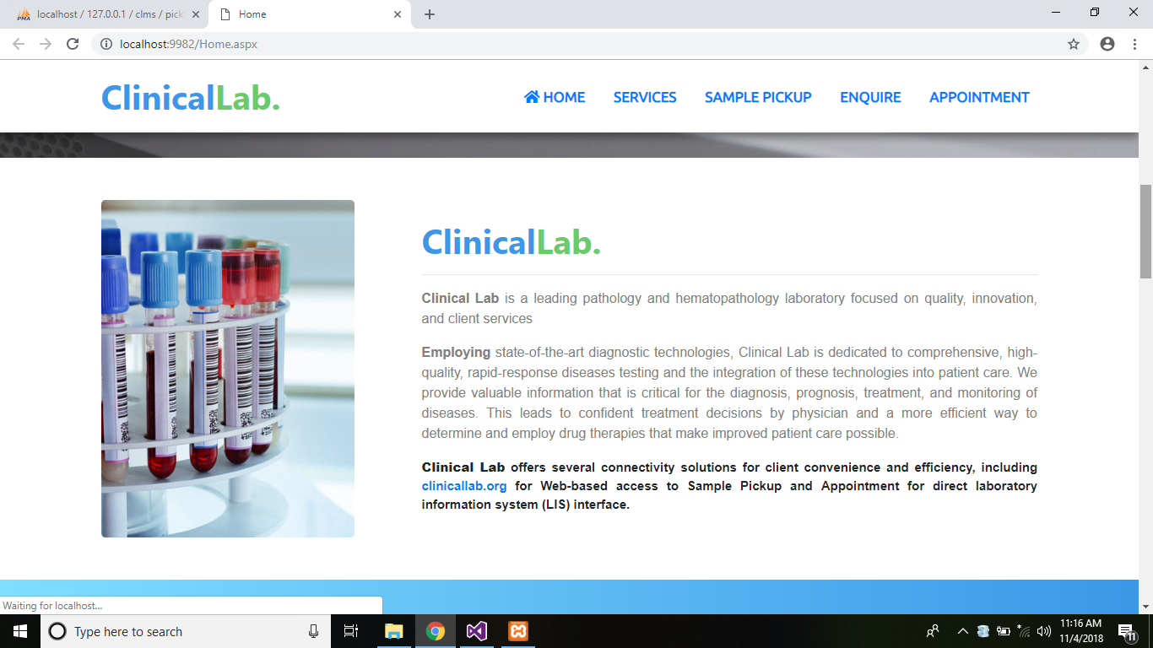

Fig 3.1: Home Page (Home.aspx)

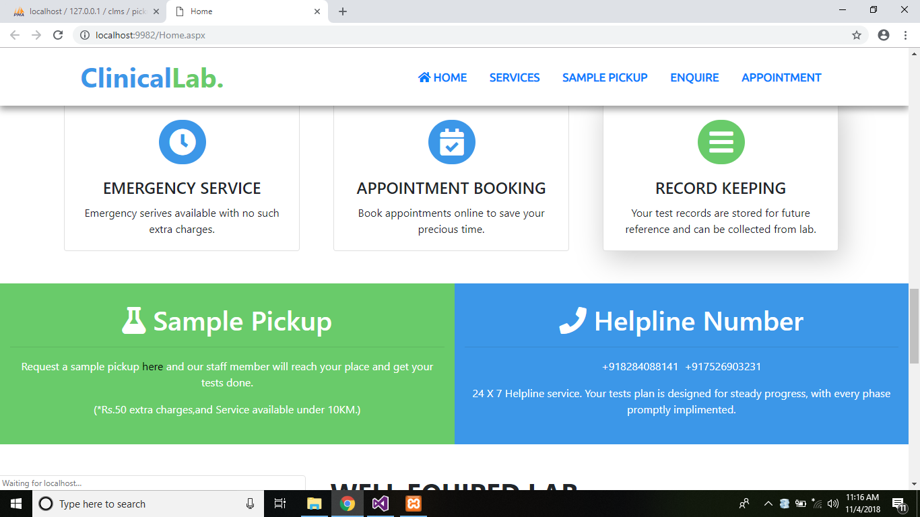

Fig 3.2: Home Page (Home.aspx)

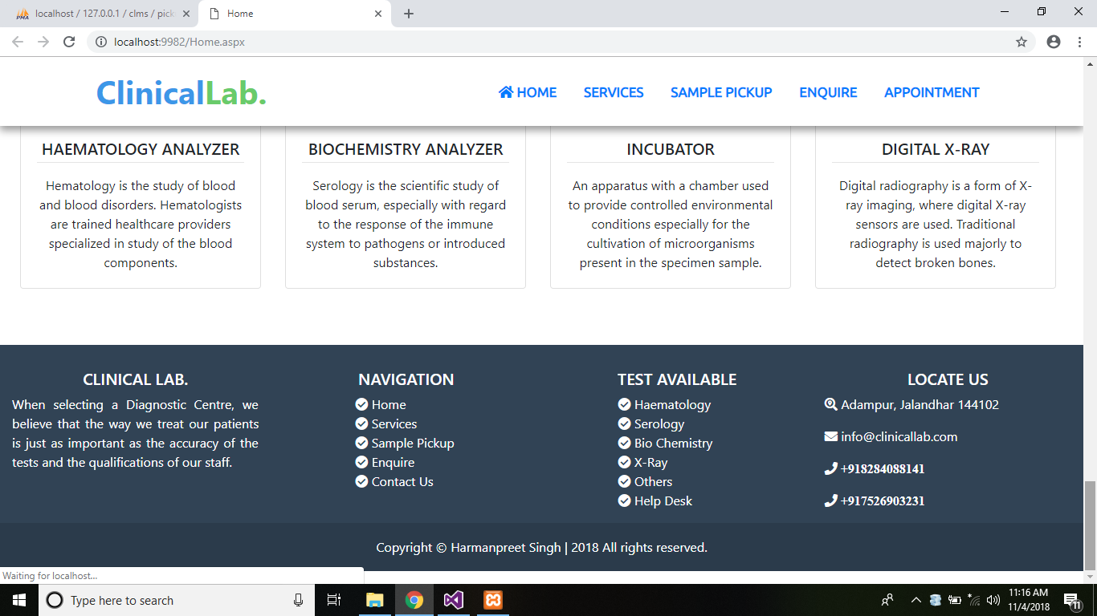

Fig 3.3: Home Page (Home.aspx)

Fig 4 shows services page which will fetch data from services relation and show it on the screen in a table.

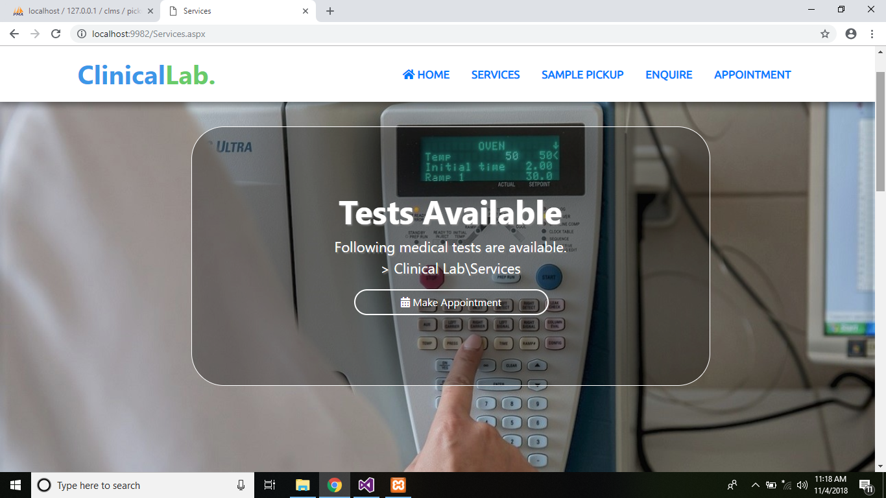

Fig 4: Services Page (Services.aspx)

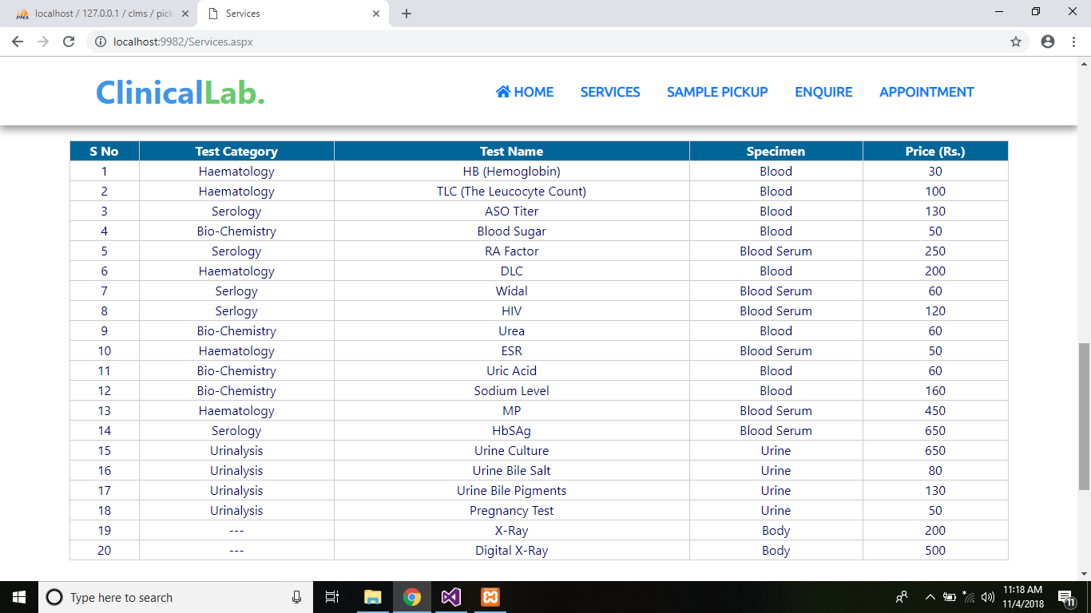Fig 4.1: Services Page showing data from database (services relation)

Fig 5 shows Sample pickup page in which user will fill the data and then the data is sent to the pickup table for storage and a unique Pickup ID will be generated.

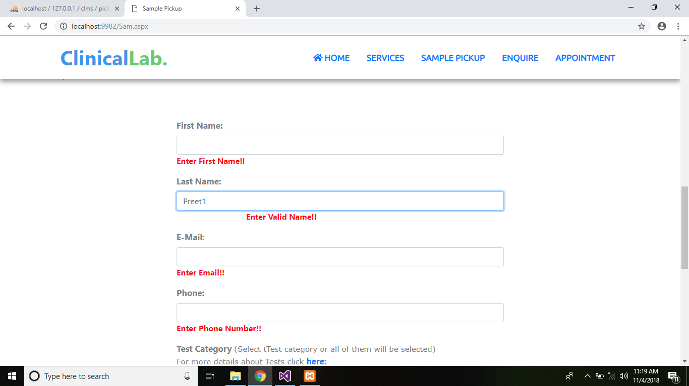

Fig 5: Sample Pickup Booking Page Form Validation

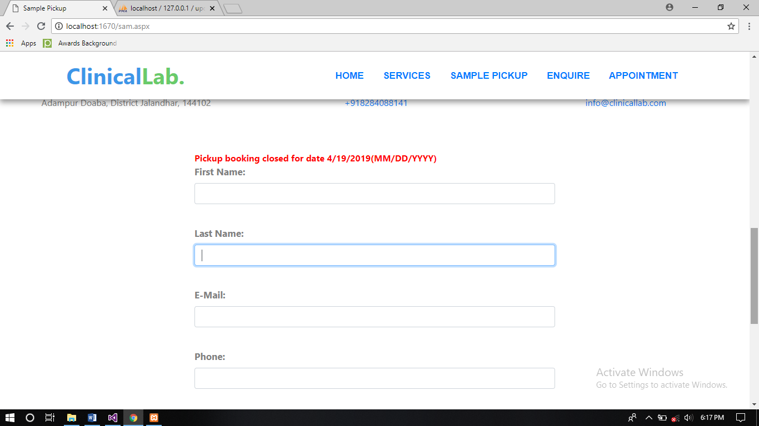

Fig 5.1: Bookings closes after 6 bookings.

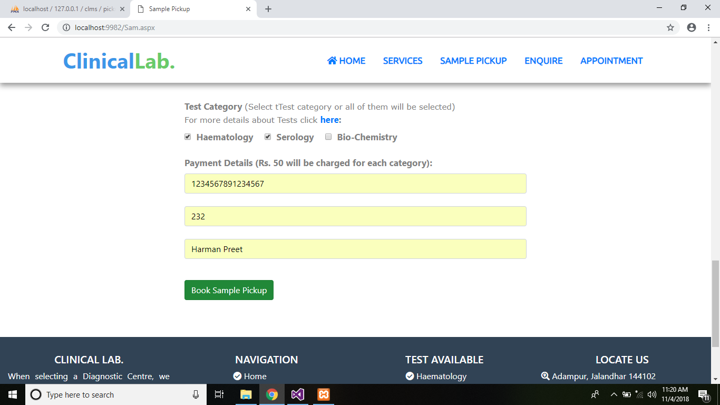

Fig 5.2: Form fill to book sample pickup.

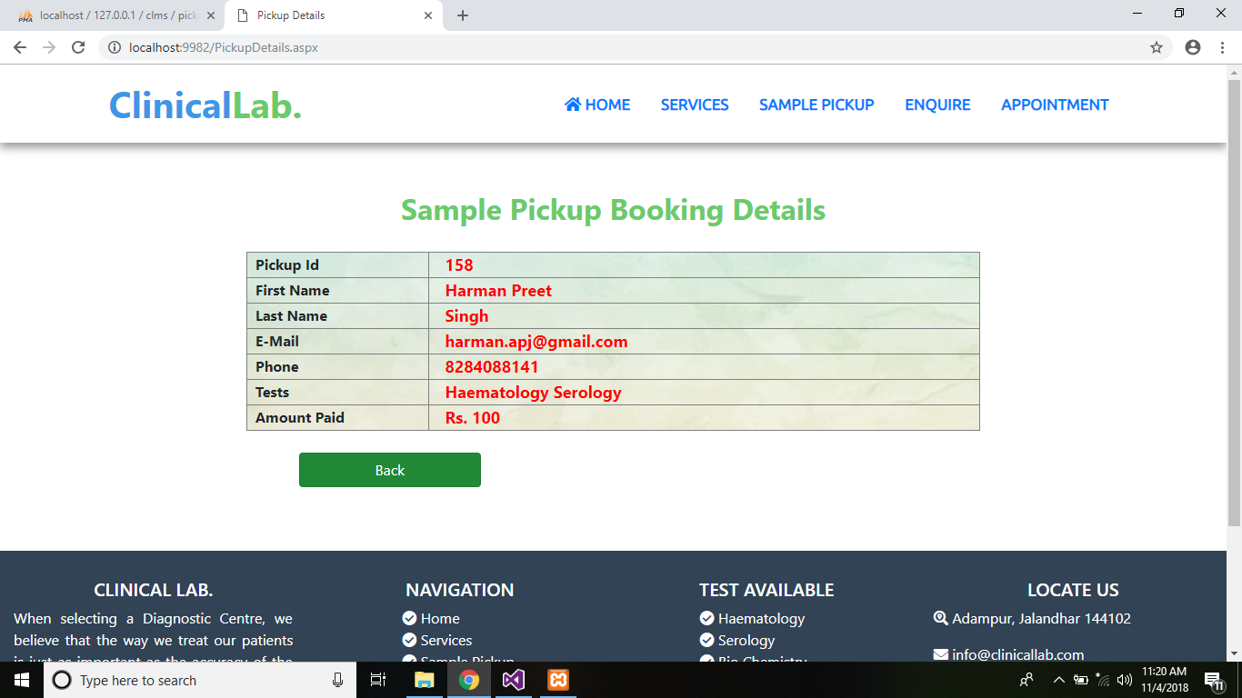Fig 5.3: Pickup Details Show with generation of Pickup ID

Fig 6 shows Enquire page in which user will fill the data and submit the form then the data is sent to the enquire table for storage and a message is printed on the screen.



Fig 6: Enquiry Page (Enquire.aspx)

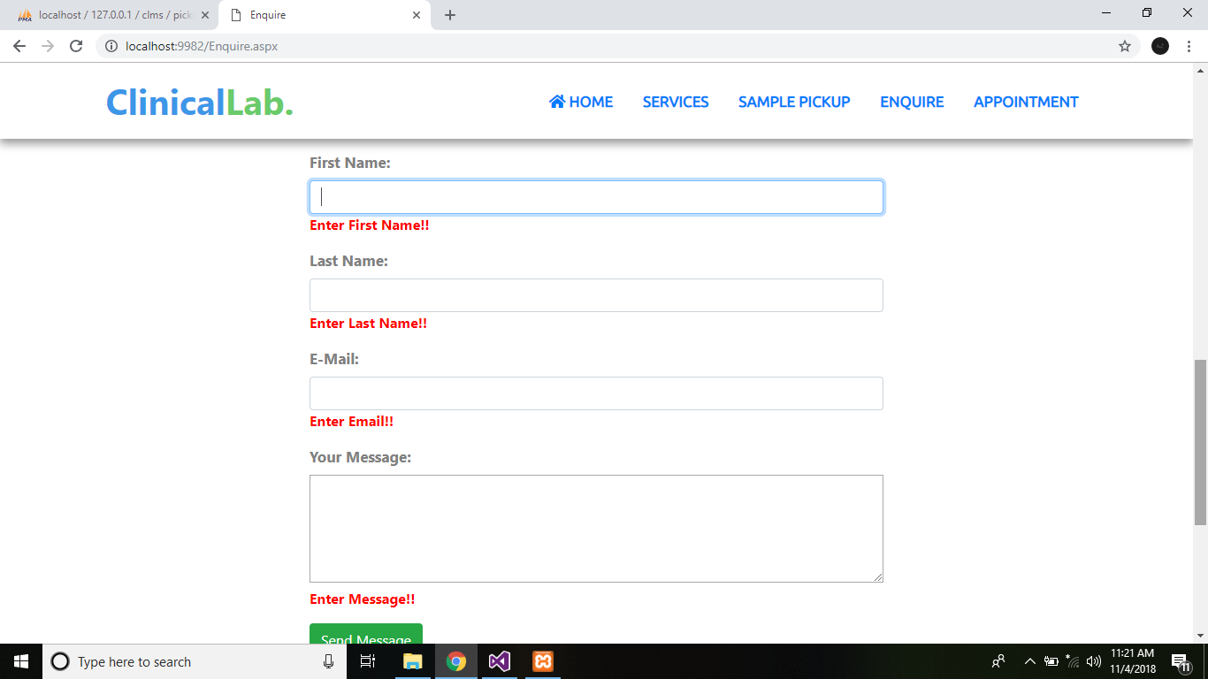

Fig 6.1: Enquiry Form Validation

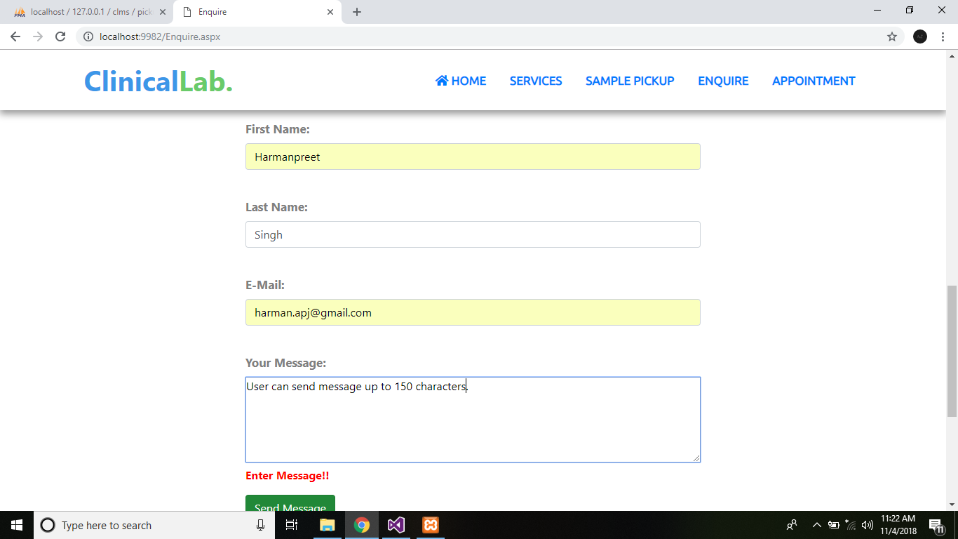

Fig 6.2: Form Fill to post enquiry

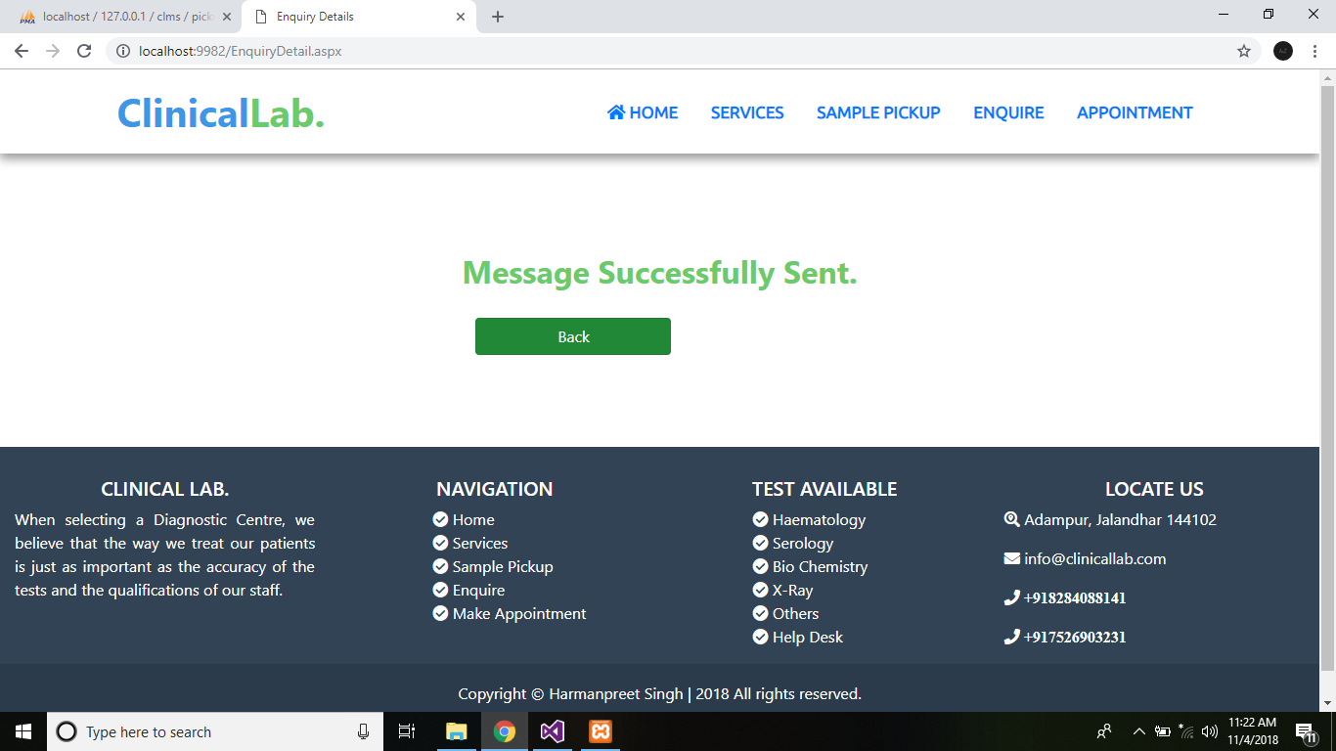

Fig 6.3: Enquiry Message Detail

Fig 7 shows Appointment Booking page in which user will fill the data and then the data is sent to the pickup table for storage and a unique Pickup ID will be generated.

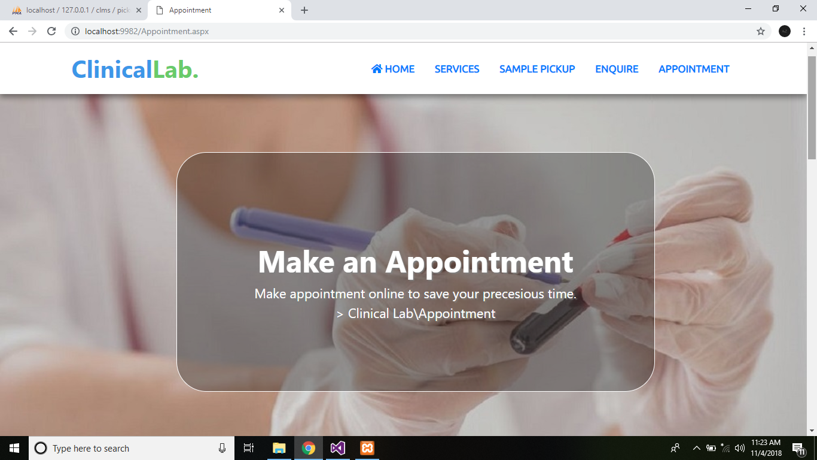

Fig 7: Appointment Booking Page (Appointment.aspx)

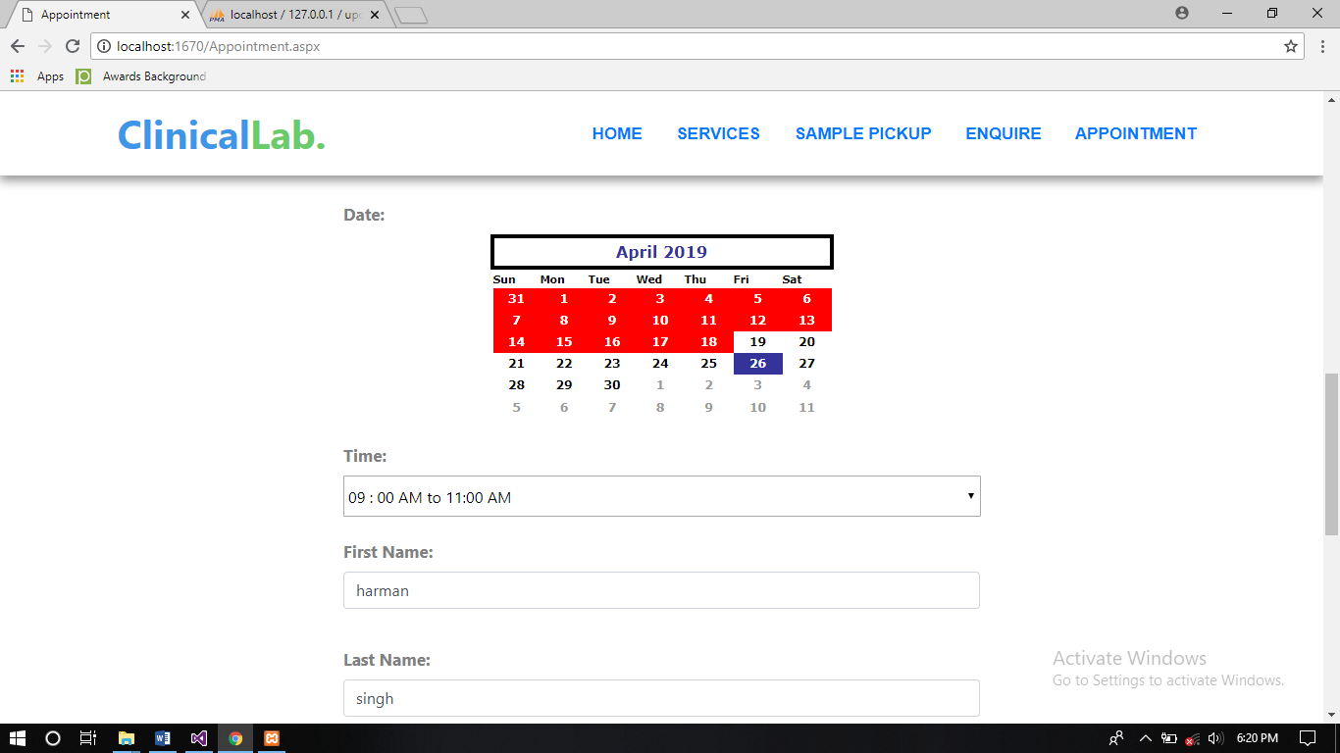

Fig 7.1: Appointment Booking Form

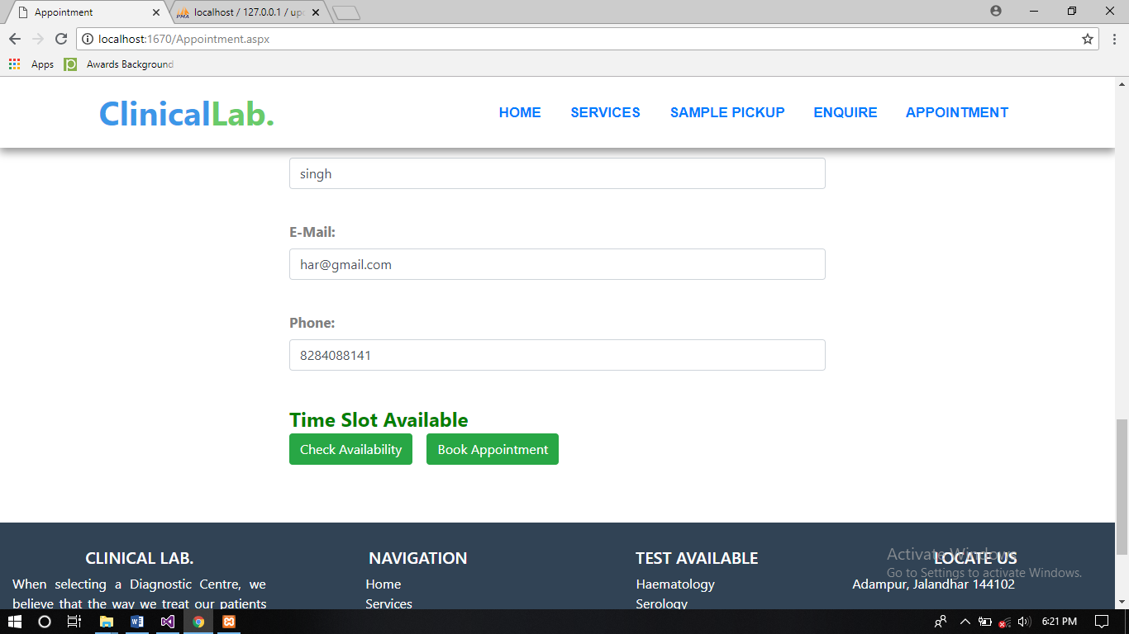

Fig 7.2: From fill to book appointment(a)

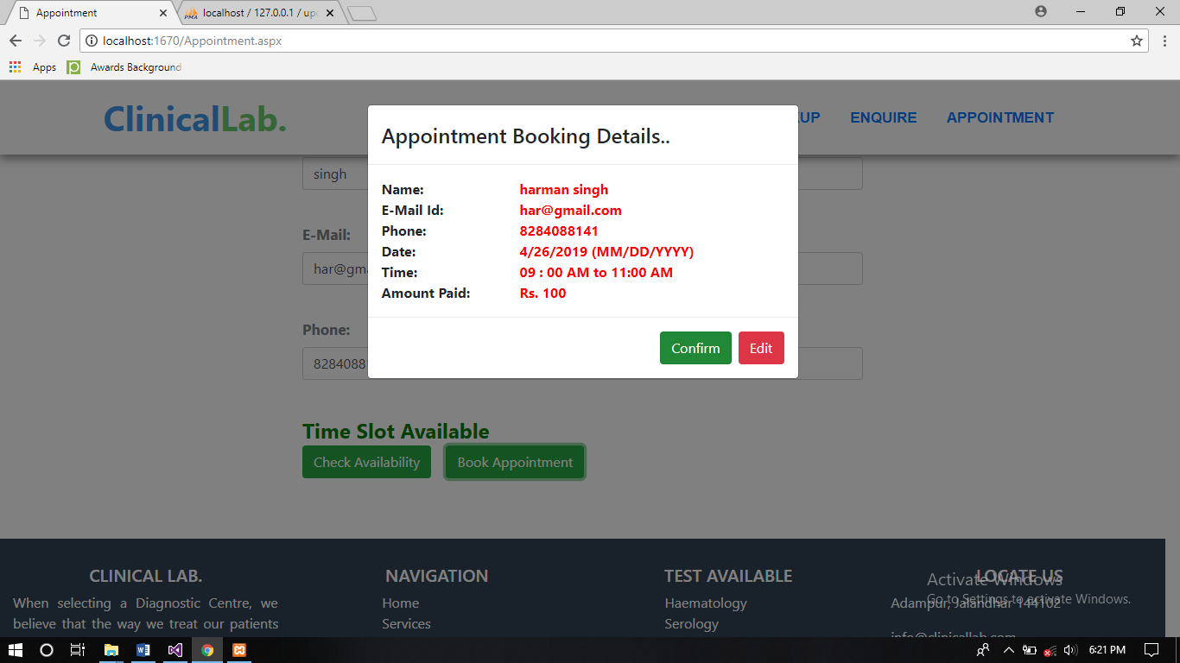

Fig 7.3: From fill to book appointment(b)

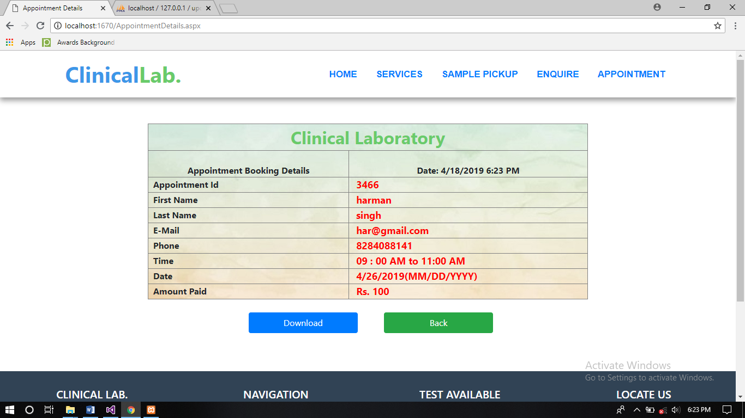

Fig 7.4: Appointment Details Show with generation of Appointment ID

**5.4 Chosen methodology**

**5.4.1 SDLC**

SDLC is a process followed for a software project, within a software organization. It consists of a detailed plan describing how to develop, maintain, replace and alter or enhance specific software. The life cycle defines a methodology for improving the quality of software and the overall development process.

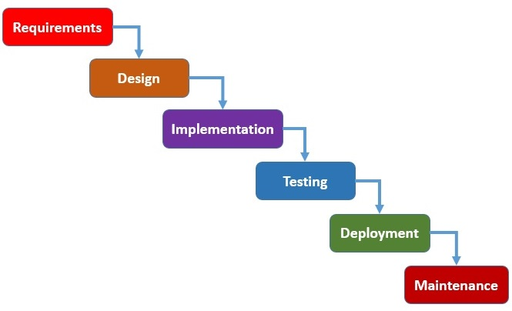

Fig 8: Software Development Life Cycle

Or, Software Development Life Cycle (SDLC) is a process used by the software industry to design, develop and test high quality software’s. The SDLC aims to produce a high-quality software that meets or exceeds customer expectations, reaches completion within times and cost estimates.

* SDLC is the acronym of Software Development Life Cycle.
* It is also called as Software Development Process.
* SDLC is a framework defining tasks performed at each step in the software development process.
* ISO/IEC 12207 is an international standard for software life-cycle processes. It aims to be the standard that defines all the tasks required for developing and maintaining software.

**5.4.2 Phases of SDLC**

**Requirement gathering and analysis:** Business requirements are gathered in this phase. This phase is the main focus of the project managers and stake holders. Meetings with managers, stake holders and users are held in order to determine the requirements like; Who is going to use the system? How will they use the system? What data should be input into the system? What data should be output by the system? These are general questions that get answered during requirements gathering phase. After requirement gathering these requirements are analyzed for their validity and the possibility of incorporating the requirements in the system to be development is also studied.

Finally, a Requirement Specification document is created which serves the purpose of guideline for the next phase of the model. The testing team follows the Software Testing Life Cycle and starts the Test Planning phase after the requirements analysis is completed.

**Design:** In this phase the system and software design is prepared from the requirement specifications which were studied in the first phase. System Design helps in specifying hardware and system requirements and also helps in defining overall system architecture. The system design specifications serve as input for the next phase of the model.

In this phase the testers come up with the Test strategy, where they mention what to test, how to test.

**Development:** On receiving system design documents, the work is divided in modules/units and actual coding is started. Since, in this phase the code is produced so it is the main focus for the developer. This is the longest phase of the software development life cycle.

**Testing:** After the code is developed it is tested against the requirements to make sure that the product is actually solving the needs addressed and gathered during the requirements phase. During this phase all types of functional testing like unit testing, integration testing, system testing, acceptance testing is done as well as non-functional testing are also done.

**Deployment:** After successful testing the product is delivered / deployed to the customer for their use.

As soon as the product is given to the customers, they will first do the beta testing. If any changes are required or if any bugs are caught, then they will report it to the engineering team. Once those changes are made or the bugs are fixed then the final deployment will happen.

**Maintenance:** Once when the customers start using the developed system then the actual problems come up and needs to be solved from time to time. This process where the care is taken for the developed product is known as maintenance.

**5.4.3 Reasons for chosen methodology**

* Customer satisfaction by rapid, continuous delivery of useful software.
* People and interactions are emphasized rather than process and tools.
* Working software is delivered frequently (weeks rather than months).
* Even late changes in requirements are welcomed.
* The SDLC methodology that proposed to develop this study contains six phases, they are: Requirements gathering, Design, Development, Implementation, Testing and Evaluation.

**5.5 System Modeling**

System modeling helps the analyst to understand the functionality of the system and models, Different models present the system from different perspectives, External perspective showing the system’s context or environment, Behavioral perspective showing the behavior of the system, Structural perspective showing the system or data architecture.

During the system requirements and design activity, systems may be modeled as a set of components and relationships between these components. These are normally illustrated

graphically in a system architecture model that gives the reader an overview of the system organization. Because of the graphical representations used, models are often more understandable than detailed natural language description of the system requirements. Examples of such modeling tool are a System Flowchart.

**5.6 Database Designing**

A database is a data structure that stores organized information. Most databases contain multiple tables, which may each include several different fields. For example, a company database may include tables for products, employees, and financial records. Each of these tables would have different fields that are relevant to the information stored in the table.

Database design is the organization of data according to a database model. The designer determines what data must be stored and how the data elements interrelate. With this information, they can begin to fit the data to the database model. Database design involves classifying data and identifying interrelationships.

**5.6.1 Relations in clms Database**

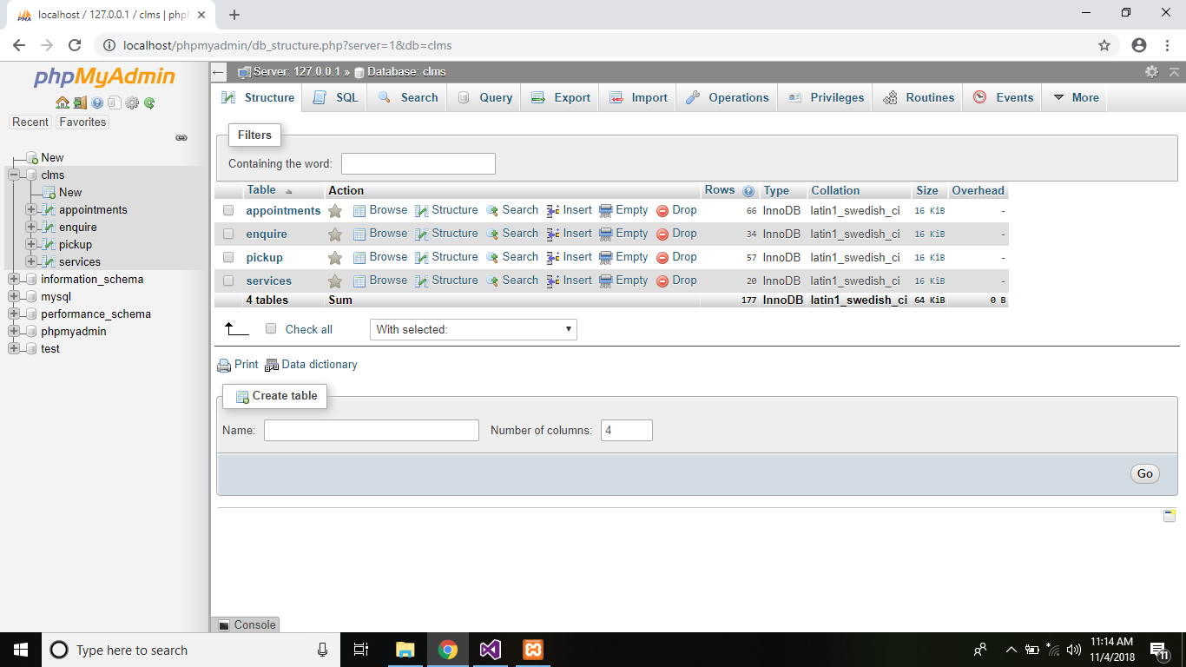

Fig 9: phpMyAdmin clms database

**5.6.2 Services Relation**

Services relation will store the data about test category, test name etc. this data will be shown to the user with services table.

|  |  |  |
| --- | --- | --- |
| **Column Name** | **Datatype (Size)** | **Constraints** |
| SNO | int (11) | Primary Key |
| TestCategory | varchar (45) | Not Null |
| TestName | varchar (25) | Not Null |
| Specimen | varchar (25) | Not Null |
| Price | int (11) | Not Null |

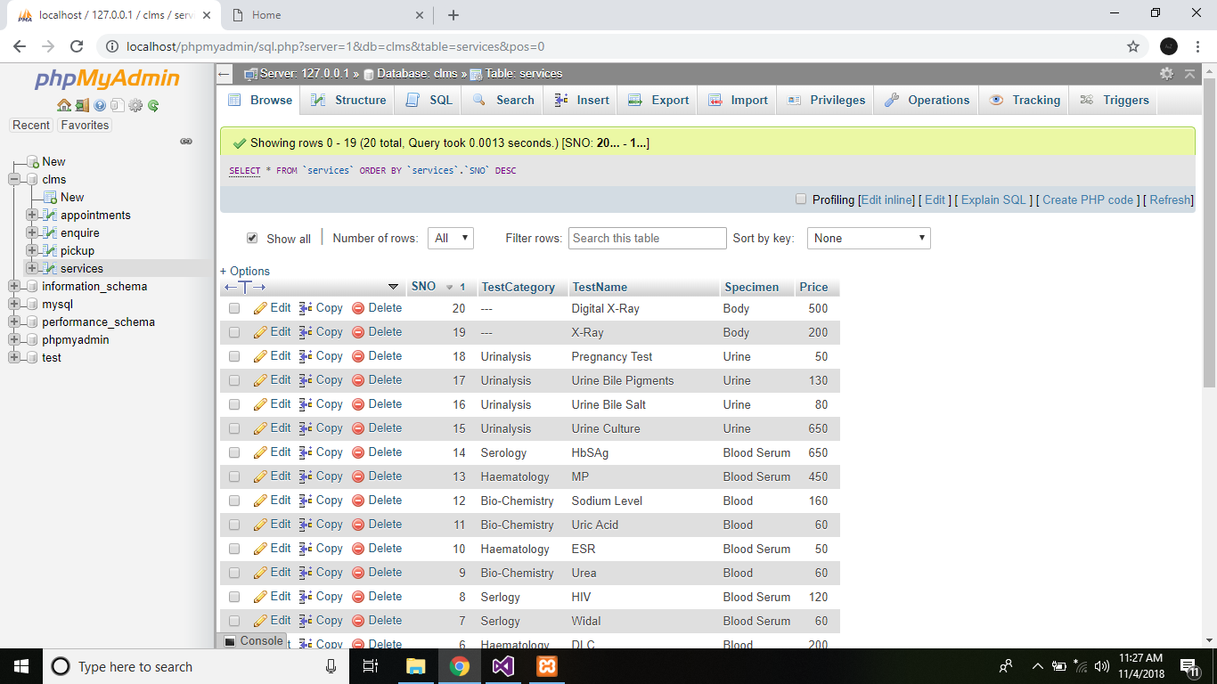

Fig 9.1: Services Relation

**5.6.3 Sample Pickup Relation**

Sample pickup relation will store the data entered by the user to book sample pickup and this relation is having a PID column which is auto incremented after each entry and this id generated by the table is then fetched and send to the pickupdetails page.

|  |  |  |
| --- | --- | --- |
| **Column Name** | **Datatype (Size)** | **Constraints** |
| PID | int (11) | Primary Key, Auto Increment |
| Fname | varchar (45) | Not Null |
| Lname | varchar (45) | Not Null |
| Mail | varchar (45) | Not Null |
| Phone | bigint (10) | Not Null |
| Testtype | Varchar (45) | Not Null |
| dated | Varchar (10) | Not Null |

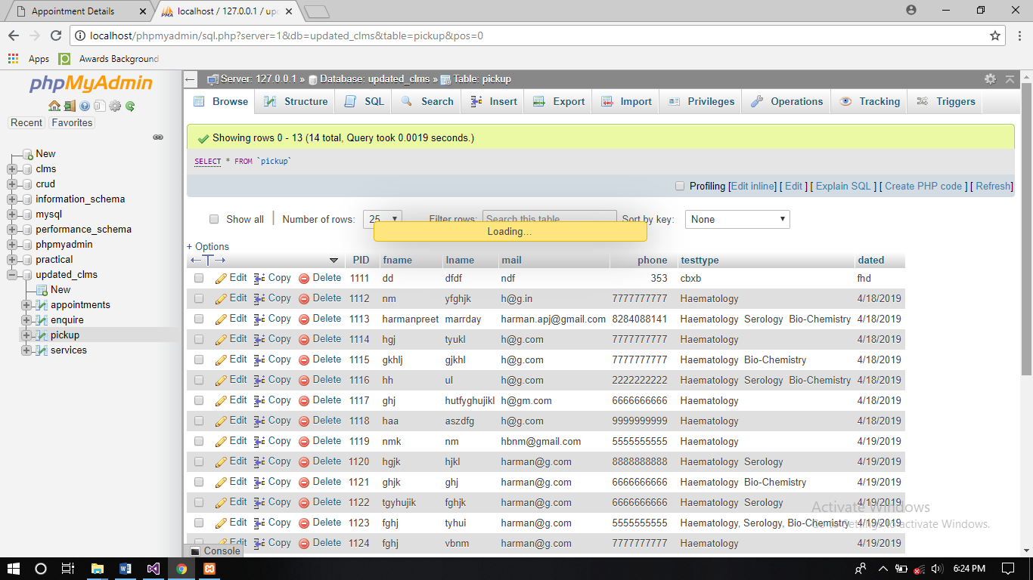

Fig 9.2: Pickup Relation

**5.6.4 Appointments Relation**

Appointments relation will store the data entered by the user to book appointment and this relation is having a appid column which is auto incremented after each entry and this id generated by the table is then fetched and send to the appointmentdetails page.

|  |  |  |
| --- | --- | --- |
| **Column Name** | **Datatype (Size)** | **Constraints** |
| appid | int (11) | Primary Key, Auto Increment |
| fname | varchar (45) | Not Null |
| lname | varchar (45) | Not Null |
| mail | varchar (45) | Not Null |
| phone | bigint (10) | Not Null |
| time | Varchar (10) | Not Null |
| date | Varchar (10) | Not Null |

Fig 9.3: Appointments Relation

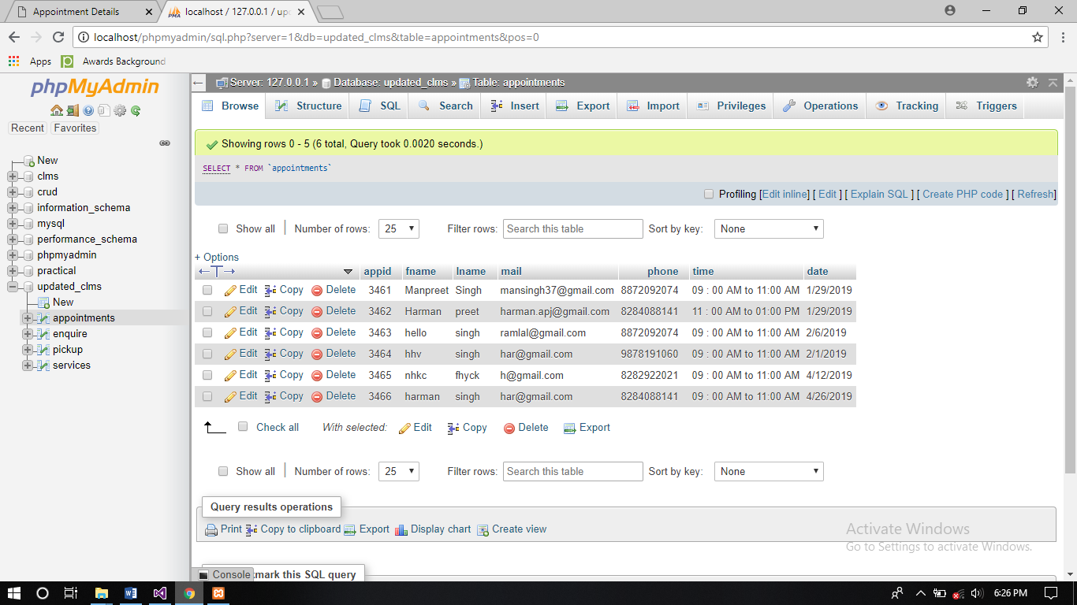

**5.6.5 Enquiry Relation**

Enquiry relation will store the data entered by the user to post a query to the laboratory and after a successful post it will send an confirmation to the page that data is stored to in the relation successfully.

|  |  |  |
| --- | --- | --- |
| **Column Name** | **Datatype (Size)** | **Constraints** |
| SNo | int (11) | Primary Key, Auto Increment |
| fname | varchar (45) | Not Null |
| lname | varchar (45) | Not Null |
| mail | varchar (45) | Not Null |
| message | varchar (200) | Not Null |

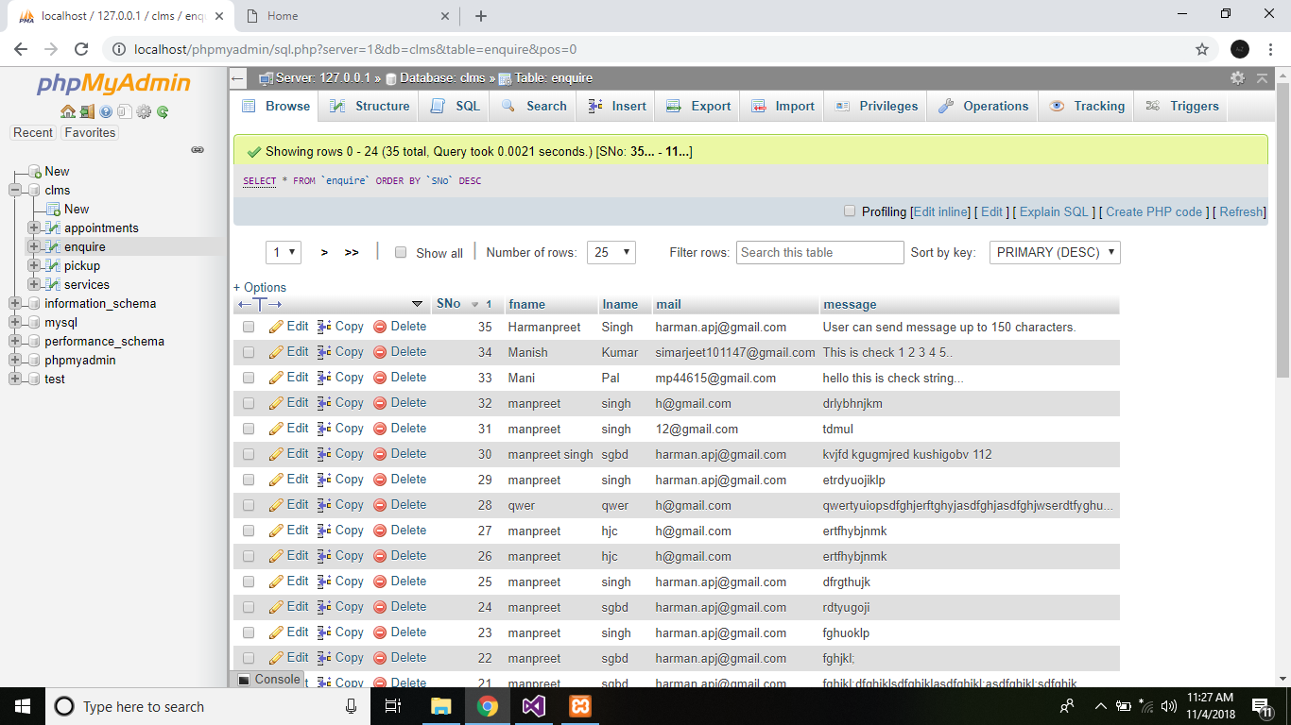

Fig 9.4: Enquire Relation